Intensive Course in English 2020- Student Hand Book

INTENSIVE COURSE IN ENGLISH
January 2020
ENGLISH LANGUAGE TEACHING UNIT
FACULTY OF DENTAL SCIENCES
UNIVERSITY OF PERADENIYA
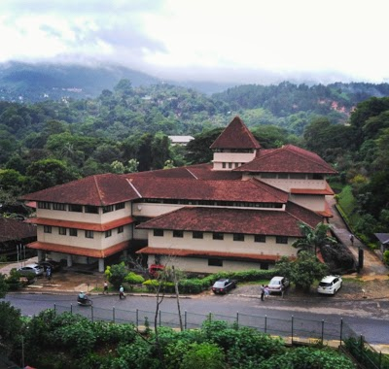
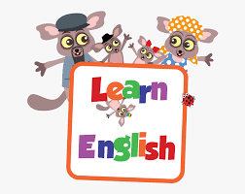
Why Learn English..?
Language is our primary source of communication. It is the method through which we share our ideas and thoughts with others. Some people even say that language is what separates us from animals and makes us human. There are thousands of languages in this world. Countries have their own national languages in addition to a variety of local languages spoken and understood by their people in different regions. Some languages are spoken by millions of people, others by only a few thousand.
English may not be the most spoken language in the world, but it is the official language in a large number of countries. It is estimated that the number of people in the world that use English to communicate on a regular basis is 2 billion.
English is the dominant business language and it has become almost a necessity for people to speak English if they are to enter a global workforce. Research from all over the world shows that cross-border business communication is most often conducted in English. Its importance in the global market place therefore cannot be understated. Learning English really can change your life.
Many of the world’s top films, books and music are published and produced in English. Therefore by learning English you will have access to a great wealth of entertainment and will be able to have a greater cultural understanding.
Most of the content produced on the internet is in English. So knowing English will allow you access to an incredible amount of information which may not be otherwise available. Although learning English can be challenging and time
consuming, we can see its importance as it can create many opportunities. There are several factors that make the English language essential for communication. First of all, it is the most common foreign language. This means that two people who come from different countries (for example, a Chinese and a Sri Lankan) usually use English as a common language to communicate. That is why everyone needs to learn the language in order to get in touch on an international level. Speaking in English will help you communicate with people from countries all over the world, not just English-speaking ones.
English is also essential to the field of education. In many countries, children are taught and encouraged to learn English as a second language. Even in countries where it is not an official language, we will find many syllabi in medicine, science and engineering written in English. As it is the dominant language in the sciences, most of the research and studies you find in any given scientific field will be written in English as well. At the university level, in many countries, almost all the courses are conducted in English.
The BDS programme (Bachelor of Dental Sciences) at the Faculty of Dental Sciences, University of Peradeniya is conducted in English language. All the teaching material is in English. Therefore, a good command of English is expected from the undergraduates
. 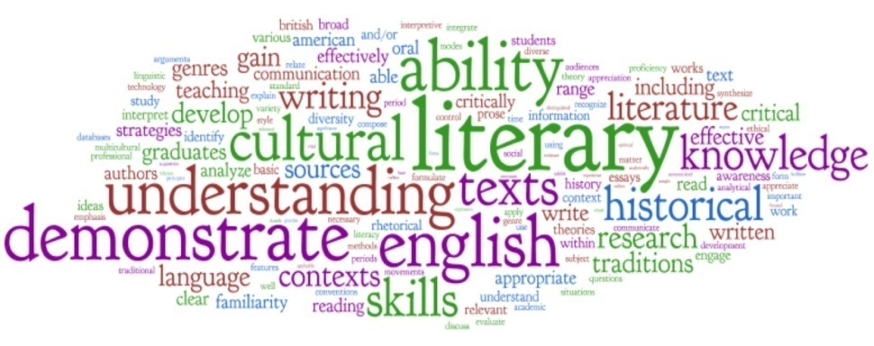

The Intensive Course in English- January 2020
The English Language Teaching Unit (ELTU) will be responsible for conducting the Intensive Programme in English for the new entrants. The course will commence on 15.01.2020.The purpose of the Intensive Course is to prepare the new entrants for the academic programme in dentistry which will be conducted in English.
During the Intensive Course, the focus will be on developing the main skills in the English language namely, Grammar& Writing, Reading & Comprehension, Speech and Listening. The course has been designed in such a way that there is continuity in the skills taught throughout the academic programme.

- Grammar & Writing
The objective of the above component is to introduce grammatical rules and structures which would enable students to engage in various writing exercises. This would include descriptions, paragraph writing, summarizing, describing processes, essay writing, letter writing etc.

- Reading & Comprehension
The purpose of this component is to test each student’s ability to read and understand a given text. Understanding a given text would mean that the student be able to answer the questions and summarize the content. Methods of skimming and scanning in reading will also be introduced.

- Speech
Engaging in speech activities would enhance students’ ability to listen, understand and respond verbally. During the course, emphasis will be on communicative activities that would involve day to day happenings, greetings, dialogues, facing interviews, impromptu speeches etc.
5
- Listening
Listening is a skill that involves students’ ability to listen to a text that is being read out or a recording, understanding and answering the given questions to the point. Short texts on current global happenings and general and academic texts will be used for this purpose.

At the end of the Intensive Course in English, the students will be assessed on all four skills.

Note: At the end of the Intensive Course in English, the ELTU organizes a variety entertainment show. Students are encouraged to display their talents at this event.

FACULTY OF DENTAL SCIENCE
Timetable-Intensive Course in English- January 2020

 | Monday |  |  | Tuesday |  |  |  | Wednesday |  |  |  |  | Thursday |  |  |  |  |  | Friday
 | G-1 | G-2 | G-3 | G-1 | G-2 | G-3 |  | G-1 |  | G-2 | G-3 |  | G-1 |  | G-2 |  | G-3 |  | G-1 |  | G-2 | G-3
8.30- 10.00 | W | W | W | W | W | W |  | W |  | W | W |  | W |  | W |  | W |  | W |  | W | W
10.20-11.20 | R | R | R | R | R | R |  | R |  | R | R |  | L |  | L |  | L |  | L |  | L | L
11.30-  01:00 | SP | SP | SP | SP | SP | SP |  | SP |  | SP | SP |  | SP |  | SP |  | SP |  | SP |  | SP |  | SP
01:00-  02:00 | LUNCH INTERVAL
02:00-  04:00 | MA | MA | MA | MA | MA | MA | MA |  | MA |  |  | MA |  | MA |  | MA |  | MA |  | MA | MA | MA
Key: G Grammar R Reading & Comprehension S Speech IT Information Technology
W Writing L Listening MA Miscellaneous Activities
Variety Entertainment Shows 2016- 2019- Memories…

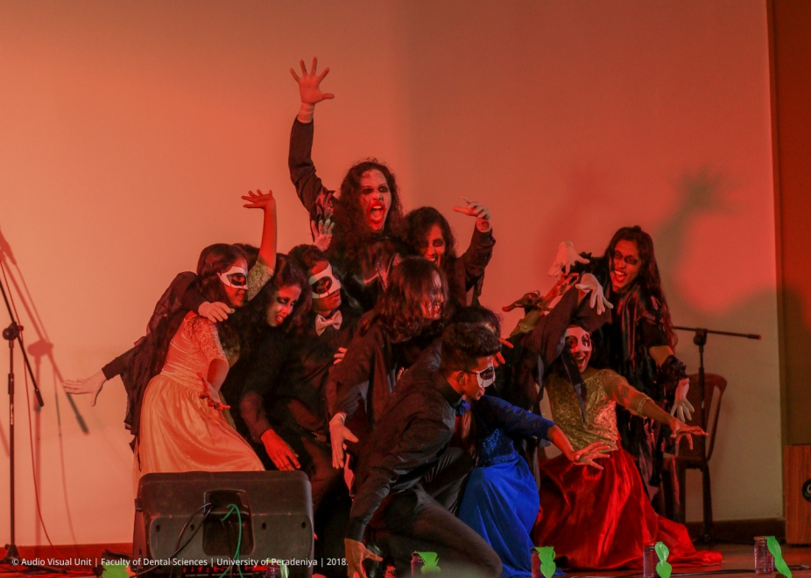

The Ongoing Course in English
DS 1107 ( Semester 1) & DS 1206 (Semester 2)

Skills Taught Content
*Semester 1
Skill
Writing Essays on academic and general topics, informal, Reading and comprehension
Informal, semi- informal and formal letter writing, summarizing and note taking

Reading Passages selected from academic texts and global topics
Assignments on Reading, Listening, In course test, Speech & Writing Exam

*Semester 2
Skill Content
Speech Situational dialogues, speeches, interviews, presentations

Listening Short academic texts, texts on global happenings, listening to recordings Assignments on Reading, Listening, In course test, Speech & Writing Exam

Assessment Scheme
A student should have 80% attendance for the Intensive English Course from the date of his/her registration. It is also compulsory to complete the ENG 1 ( DS1107) and ENG 2 (DS1206) courses (obtain 50% of the total marks) in order to complete the BDS degree.
Assessment |  | Percentage Marks
In-course |  | 30%
End-semester | Theory | 30%
 | Practical | 40%

The ELTU conducts extra English classes on request.

English Language Teaching Unit
Faculty of Dental Sciences
Staff
Convener- Prof. J.A.M.S. Jayatilake
Coordinator- Mrs. Dulshika Senanayake
Instructors – Mrs. Azna Deen
Ms. Monika Jayasekara

